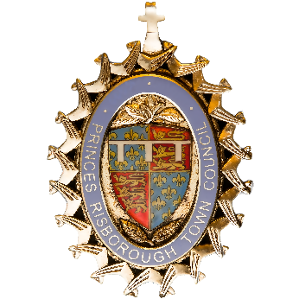
PRINCES RISBOROUGH TOWN COUNCIL

ANNUAL TOWN MEETING

THE ANNUAL TOWN MEETING WILL BE HELD ON
TUESDAY 18TH APRIL 2023 AT 7.15PM

AT THE BRUSHWOOD SUITE, WADES CENTRE
PRINCES RISBOROUGH

AGENDA

- Welcome by the Town Mayor

- Introduction of Members of the Council

- Chairman’s report

- To receive reports from the Committees Chairperson

- Question and Answers

- Refreshments

- The Town Mayor to make Presentation of Princes Risborough Citizens Awards

Cllr Andy Ball – Town Mayor
27th March 2023

