Princes Risborough Town Council

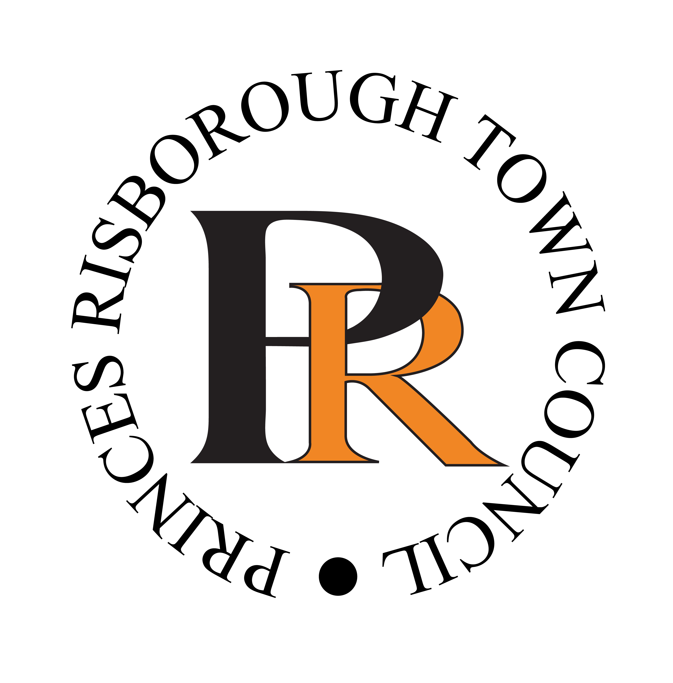

2019 Art in the Park Application Form
First Name: Last Name:
Address:

Email: Contact Number:
Website (if applicable):

MEDIA: PLEASE SELECT YOUR PRIMARY MEDIA CATEGORY.
Ceramics
Digital

Drawing
Glass
Painting on Canvas
Paper
Photography
Sculpture
Wood
Other Please state other: …………………………………………………………………………………………………
Have you entered Art in the Park before?: Yes No
Do you give permission to use you name for publicity purposes? Yes No
For further on our privacy policy please visit our website www.princesrisboroughtowncouncil.gov.uk
Please give us a description of your submitted piece:

Date:
Send application with high resolution image to kirsty@princesrisboroughtowncouncil.gov.uk
CLOSING DATE FOR ALL ENTRIES 10th MAY 2018

